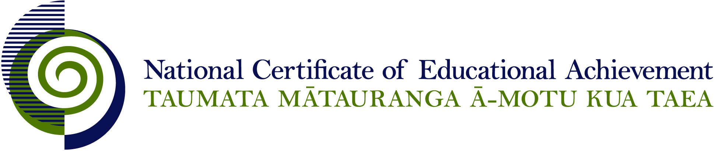

NCEA Level 3 Home Economics

Conditions of Assessment

General Information

Subject Reference | Home Economics
Domain | Home Economics
Level | 3
________________________________________________________________________

Conditions of Assessment

These Conditions provide guidelines for assessment against internally assessed Achievement Standards. Guidance is provided on:
- specific requirements for all assessments against this Standard
- appropriate ways of, and conditions for, gathering evidence
- ensuring that evidence is authentic.

Assessors must be familiar with guidance on assessment practice in learning centres, including enforcing timeframes and deadlines. The NZQA website offers resources that would be useful to read in conjunction with these Conditions of Assessment.

The learning centre’s Assessment Policy and Conditions of Assessment must be consistent with NZQA’s Assessment Rules for Schools with Consent to Assess. This link includes guidance for managing internal moderation and the collection of evidence.

Gathering Evidence

Internal assessment provides considerable flexibility in the collection of evidence. Evidence can be collected in different ways to suit a range of teaching and learning styles, and a range of contexts of teaching and learning. Care needs to be taken to allow students opportunities to present their best evidence against the Standard(s) that are free from unnecessary constraints.

It is recommended that the design of assessment reflects and reinforces the ways students have been learning. Collection of evidence for the internally assessed Standards could include, but is not restricted to, an extended task, an investigation, digital evidence (such as recorded interviews, blogs, photographs, or film), or a portfolio of evidence.

Effective assessment should suit the nature of the learning being assessed, provide opportunities to meet the diverse needs of all students, and be valid and fair.

Where all, or a significant part, of the evidence for assessment is presented orally, this will need to be recorded (audio or video) and annotated for in-school and national moderation purposes. Note that the judgement made about the quality of the work is not made on the quality of the ‘oral performance’ but the meaning inherent in the verbal presentation (or in the written notes students will likely prepare to support the presentation).

Ensuring Authenticity of Evidence

Authenticity of student evidence needs to be assured regardless of the method of collecting evidence. This must be in line with the learning centre’s policy and NZQA’s Assessment Rules for Schools with Consent to Assess.

Ensure that the student’s evidence is individually identifiable and represents the student’s own work. The evidence must be an accurate reflection of what the student independently knows and can do, according to the Standard being assessed. This includes evidence submitted as part of a group assessment, evidence produced outside of class time or without assessor supervision, and evidence produced with any use of generative artificial intelligence tools (GenAI). GenAI use should be carefully considered in the context of the Standard being assessed and its Conditions of Assessment, discussed with students before the assessment, and its use must be acknowledged. For example, an investigation carried out over several sessions could include:
- teacher guidance on the nature and extent of acceptable GenAI use, if any
- assessor observations and conversations
- meeting with the student at set milestones or checkpoints
- the student’s record of progress, such as photographic entries or any GenAI prompts used.

Specific Information for Individual Internal Achievement Standards

Achievement Standard Number | 91466 Home Economics 3.1
Title | Investigate a nutritional issue affecting the well-being of New Zealand society
Number of Credits | 5
Version | 1

NB: It is important to read the section “For All Standards” at the start of this document.

Achievement Standard Number | 91467 Home Economics 3.2
Title | Implement an action plan to address a nutritional issue affecting the well-being of New Zealand society
Number of Credits | 5
Version | 1

NB: It is important to read the section “For All Standards” at the start of this document.

This assessment is to be completed during and after students have carried out an action plan to address a nutritional concern. The developing and implementing stages of the action plan is likely to be a group activity; however, the teacher needs to ensure authenticity of individual student contributions. The ongoing reflection and evaluation must be done individually. It is necessary to collect this evidence during the process.

Achievement Standard Number | 91468 Home Economics 3.3
Title | Analyse a food related ethical dilemma for New Zealand society
Number of Credits | 5
Version | 1

NB: It is important to read the section “For All Standards” at the start of this document.

Achievement Standard Number | 91469 Home Economics 3.4
Title | Investigate the influence of multinational food corporations on eating patterns in New Zealand
Number of Credits | 5
Version | 1

NB: It is important to read the section “For All Standards” at the start of this document.

